**Course: Algorithm**  
**Prof. Prem Nair**  
**Student: Binh Van Tran**  
**ID: 986648**  
**Homework: Lab 12**

1. **Question 1 –** Playing with induced graphs

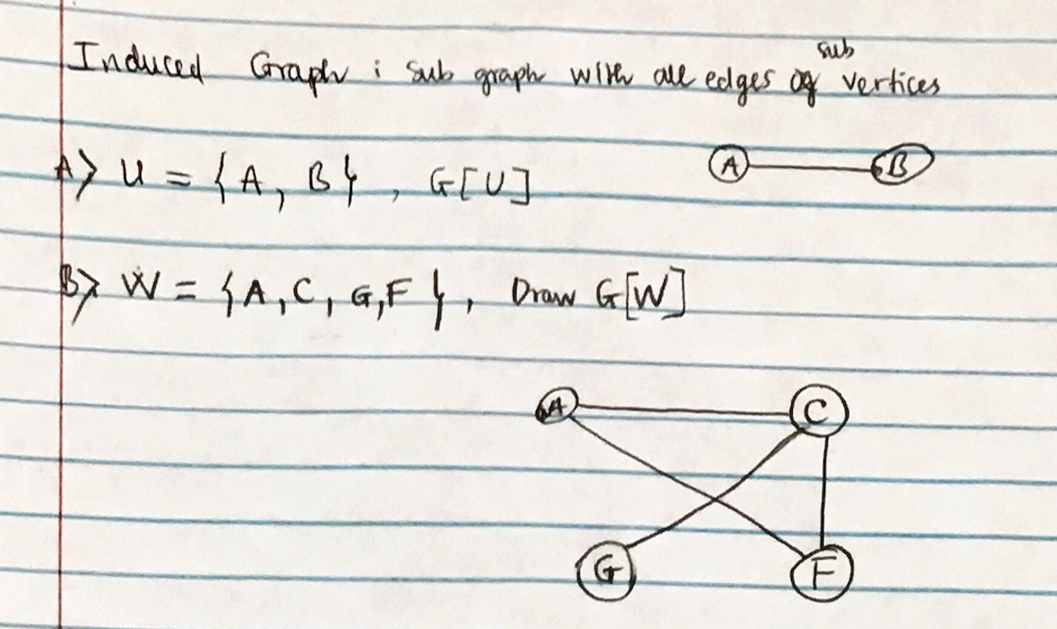

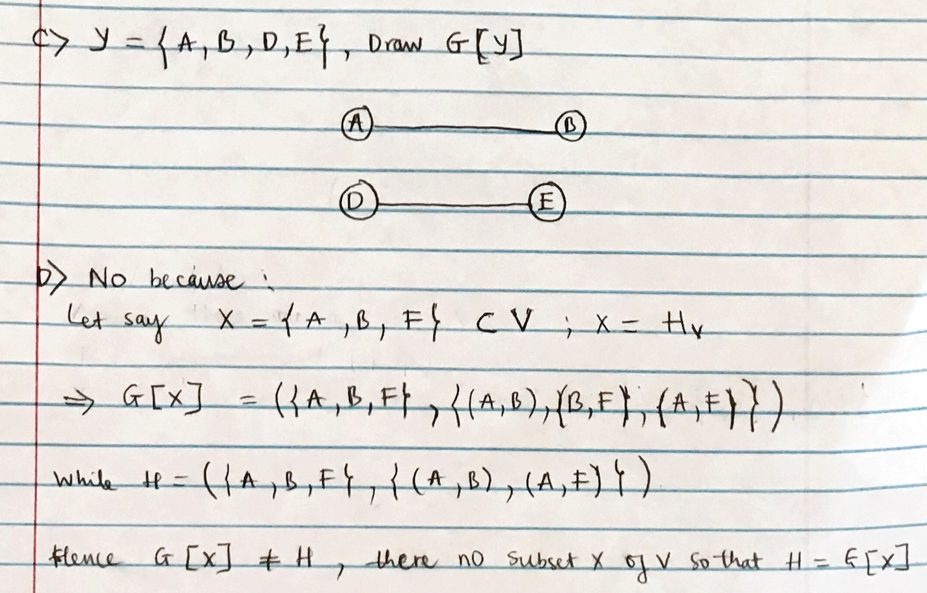

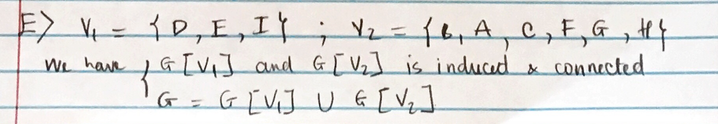

1. **Question 2 –** Finding Hamiltonian cycle

